Name: Simone Williams

Title: QR Code Cards

Exemplar:
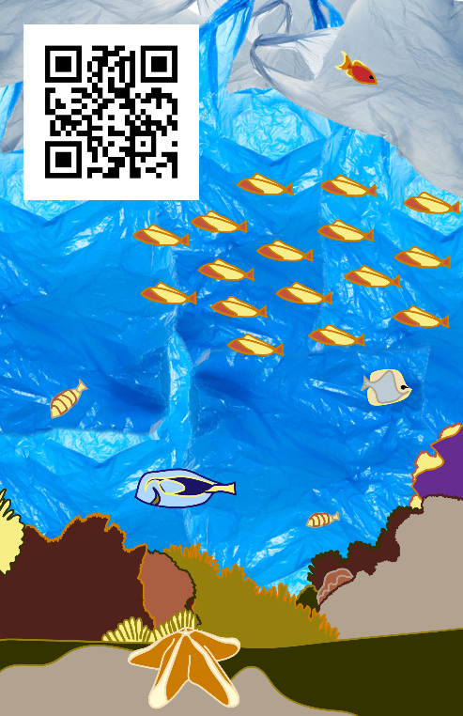

Grade level: 6th - 8th

Goal/Activity: Students will create a QR code cards after visiting the National Museum of Natural History

History/background: “We steward a collection of 145 million specimens and artifacts. Each one reflects a moment in space and time; in these moments we find Earth’s story. And our researchers continue to glean critical new information from these objects. These discoveries about the past help us model and anticipate the future.
Our exhibits, our educational programs, and our staff and volunteers share our collections and the knowledge drawn from them with millions of visitors every year – deepening their appreciation for science, the natural and cultural world, and the challenges of our time.”

Standards:
Standard - 9.1.3.B - Recognize, know, use and demonstrate a variety of appropriate arts elements and principles to produce, review and revise original works in the arts.
Standard - 9.1.5.E - Know and demonstrate how arts can communicate experiences, stories or emotions through the production of works in the arts.
Standard - 9.2.8.A - Explain the historical, cultural and social context of an individual work in the arts.
Standard - 9.2.8.F - Know and apply appropriate vocabulary used between social studies and the arts and humanities.

Objectives:
1. Knowledge: (Cognitive-Head) - Students will be able to select an exhibit from the National Museum of Natural History to further research in order to illustrate its history or significance.
2. Skill: (Psychomotor-Hands) - Students will create QR codes cards in order to share their researched information. Students will be able to apply digital tools to gather, evaluate, and use information to further research 1 exhibit from the NMNH in order to use Photoshop or Illustrator to digitally design QR code cards with visual representations of the information discovered.
3. Attitude: (Affective-Heart) - Students will be able to visually share what they found in research in order to explore ways of retaining information.

Teacher preparation: Photoshop and illustrator template for QR code cards, presentation on intro to lesson and tips to navigate through the NMNH virtual guides, obtain QR code generating site link.

Supplies: School or personal computer.

Resources: The National Museum of Natural History website.

Prior Knowledge: Students have completed written research projects for their history classes. Students have worked with both Illustrator and Photoshop.

Teaching
Motivation:
Teacher: Today we will be taking a virtual trip to the National Museum of Natural History which is located in Washington DC. I will help you navigate through the website but you are free to explore it and the many tours and activities they have provided. I would you all to choose one exhibit that interest you and create a QR code card for that exhibit.

*Places QR code generator into chat or anywhere accessible by students*

Teacher: You can use either Photoshop or Illustrator to design these cards, I have created a template for both. You can physically draw then scan in text and images, trace images or upload from google, but you card must have a clear composition and your understanding of the significance or history of your chosen exhibition should be clear.

Teacher: The link that you will generate as a QR code will be 1 additional source of informational for the exhibit you chose. You can link a document with information typed and more than 1 link or you can just link an additional website. You will be assessed on you overall understanding of the significance or history of your chosen exhibition.

Teaching
Demonstration and Directions:
*Students visit NMNH website.*
Teacher: There is a lot to explore on this website, I will show you a few things you things you can look at.
*Students look at exhibits and begin gathering information.*
*Students create usable QR codes with at least 1 source linked*

Teacher: Make sure your QR code are saved as a ‘png’.

*Students upload QR codes to Photoshop or Illustrator and being designing cards.*

Teaching
Closure: Teacher: How can you use this process to study or as research for other classes? Do you value the exhibition after visually interpreting the information you found?

Vocabulary: QR code, Research, Template, Space, Composition

Assessment: Students will be assessed based on their research and visual translation of their research.

Accommodations/Modifications/Adaptations: Sign, visual instructions or translated instructions will be used for ELL Students. Adaptive computer or computer settings and guardian assistance will be employed for students with special needs.

Extensions: Early finishers can create another QR code card for another exhibit but with no requirements.

Correlated Activity: Using the NMNH virtual tours to create a fictional habitats.

Time Budget:
Class 1 (45 minutes period):
Introduction of project (10 minutes)
Students explore NMNH website (30 minutes)
Informing students to have chosen an exhibition by next class (5 minutes)
Class 2 (45 minute period):
Warmup question (5 minutes)
Students assisted with generating QR codes (5 minutes)
Students download templates and begin designing on Photoshop or Illustrator (30 minutes)
Student progress check in (5 minutes)
Class 3 (45 minutes period):
Warmup question (5 minutes)
Students continue working on QR code card designs (40 minutes)
Class 4 (45 minute period):
Warmup question (5 minutes)
Students finish working on QR code card designs and email them to me to be printed. (20 minutes)
Virtual swapping of code cards and discussion (20 minutes)

Bibliography/references:
https://naturalhistory.si.edu/visit/virtual-tour

https://naturalhistory.si.edu/explore-at-home

https://www.qrstuff.com/

